**Practical No. 1: Install and configure Python IDE**

**Name: Suyog Chavan**

**Roll No: 71 Tyco**

1. **Title:**

Install and configure Python IDE

1. **Course Outcome(s)**

• Display message on screen using Python script on IDE

1. **Practical Outcome (PrOs)**
2. Setup a Python programming development environment
3. **Practical Related Questions:**
4. Write steps for installing Python on window

🡪 Steps to install python on windows:

1. Select version of Python to Install

The version you need depends on what you want to do in Python. For example, if you are working on a project coded in Python version 2.6, you probably need that version. If you are starting a project from scratch, you have the freedom to choose.

1. download Python Executable installer
   1. Open your web browser and navigate to the Downloads for Windows section of the official Python website.
   2. Search for your desired version of Python. At the time of publishing this article, the latest Python 3 release is version 3.7.3, while the latest Python 2 release is version 2.7.16.
   3. Select a link to download either the Windows x86-64 executable installer or Windows x86 executable installer. The download is approximately 25MB.

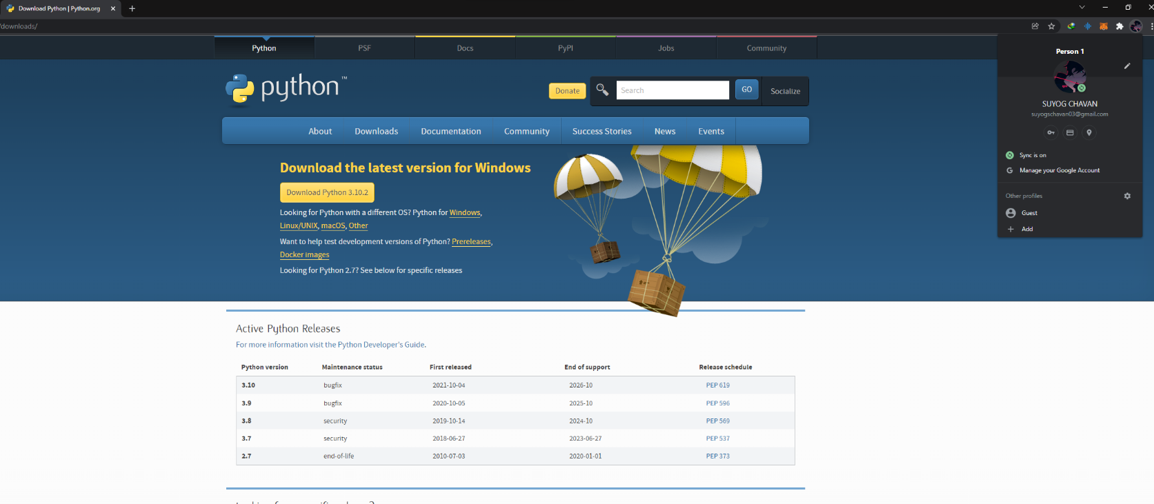

1. Run Executable Installer

1. Run the Python Installer once downloaded. (In this example, we have downloaded Python 3.10.2.)

2. Make sure you select the Install launcher for all users and Add Python 3.10 to PATH checkboxes. The latter places the interpreter in the execution path. For older versions of Python that do not support the Add Python to Path checkbox, see Step 6.

3. Select Install Now – the recommended installation options.

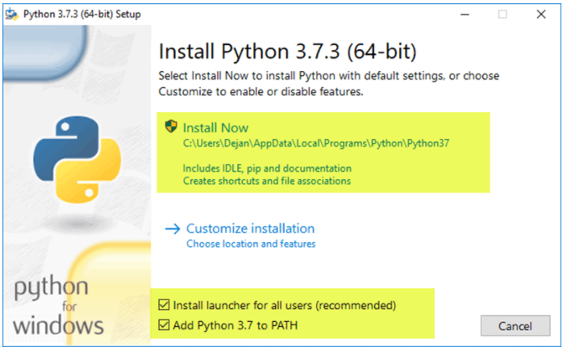

4. The next dialog will prompt you to select whether to Disable path length limit. Choosing this option will allow Python to bypass the 260-character MAX_PATH limit. Effectively, it will enable Python to use long path names.

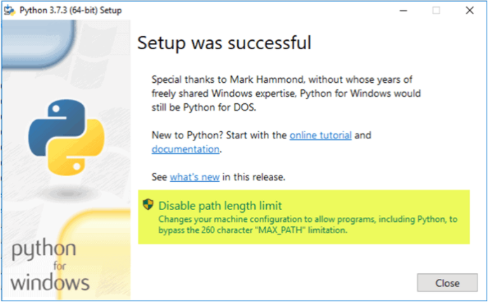

1. Verify Python was installed on windows
2. Navigate to the directory in which Python was installed on the system. In our case, it is C:\Users\Username\AppData\Local\Programs\Python\Python37 since we have installed the latest version.
3. Double-click python.exe.
4. The output should be similar to what you can see below:

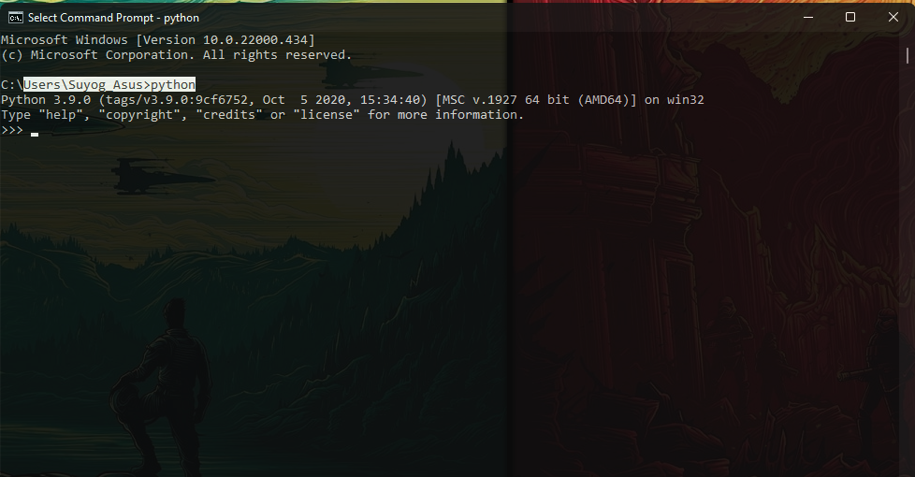

1. State IDLE in Python.

🡪 IDLE is Python’s Integrated Development and Learning Environment. It allows programmers to easily write Python code. Just like Python Shell, IDLE can be used to execute a single statement and create, modify, and execute Python scripts. In IDLE, we write code line by line. Each specific line will handle one thing, and you can type whatever you want in that line and press enter to execute it. IDLE works more like a terminal or command prompt - You write one line, press enter, it executes.

1. List key features of Python.

🡪 follows are some features of Python

1. Easy to learn and use
2. Expressive Language
3. Interpreted Language
4. Cross-platform Language
5. Free and open source
6. Object oriented Language
7. Extensible
8. Large standard Library
9. GUI Programming Support
10. Integrated
11. Embeddable
12. Dynamic Memory Allocations
13. Explain Python Path.

🡪 That is used to assist OS in calling an executable from anywhere which means if you just type Python on your Command Window, the system will look into the PATH to see which directories might contain an executable named Python.

1. State the use of pep and pip.

🡪 Use of pip - pip is a package manager which is used to install and manage additional libraries.

Use of pep - PEP (Python Enhancement Proposal) is a design document that provides information to the python community.

1. **Exercise**
2. **Print the version of Python**

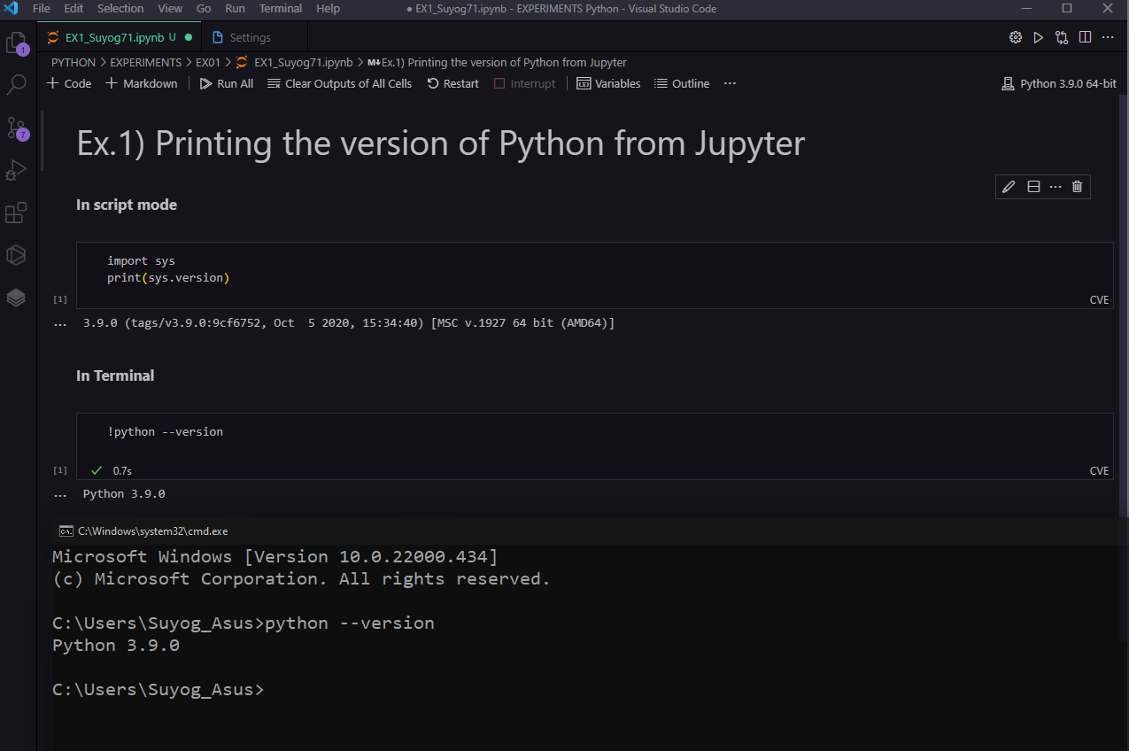

1. **Write steps to be followed to load Python interpreter in windows.**

* Following are steps to be followed to load python interpreter in windows.
  1. Open system properties.
  2. Click on Advanced system settings in the sidebar.
  3. Click environmental variables.
  4. select PATH in the system variable section.
  5. click on edit.
  6. Apply python path to the end of the list.